**Ideation Phase**

**Brainstorm & Idea Prioritization**

|  |  |
| --- | --- |
| Date | 19 September 2022 |
| Team ID | PNT2022TMID51001 |
| Project Name | Estimate The Crop Yield Using Data Analytics |
| Maximum Marks | 4 Marks |

**Brainstorm & Idea Prioritization :**

Brainstorming provides a free and open environment that encourages everyone within a team to participate in the creative thinking process that leads to problem solving. Prioritizing volume over value, out-of-the-box ideas are welcome and built upon, and all the team members are encouraged to collaborate, helping each other develop a rich amount of creative solutions.

**The Brainstorming and Idea Prioritization** <https://app.mural.co/t/brainstormingideasandideapri1077/m/brainstormingideasandideapri1077/1664097736580/f4dc11e9fe5fb568c3943fd8c6b573f5a20735ac?sender=u158e10a73002e3967fbb5783>

**Step-1: Team Gathering, Collaboration and Select the Problem Statement**

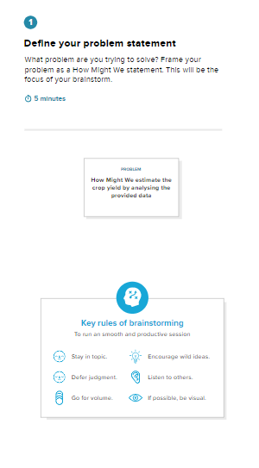

The problem statement is defined as “**How Might We estimate the crop yield by analysing the provided data”.**

**Step-2: Brainstorm, Idea Listing and Grouping**

The ideas provided by the team members are

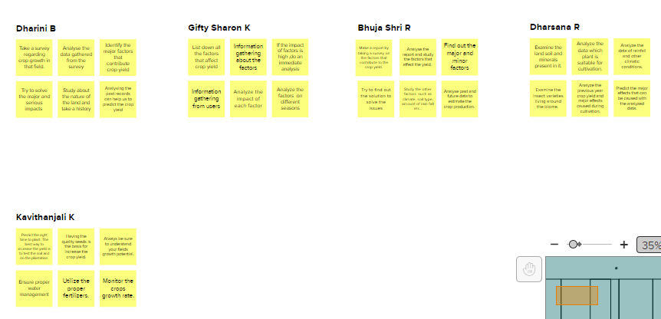

Team Leader – Dharini B has proposed the following Ideas.

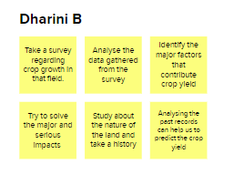

Team Member – Gifty Sharon K has proposed the following Ideas

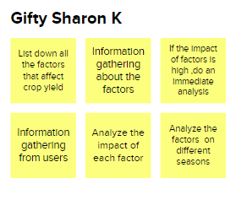

Team Member – Bhuja Shri R has proposed the following Ideas

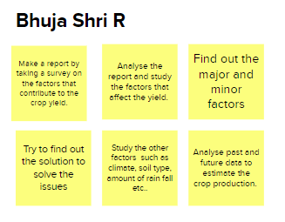

Team Member – Dharshana R has proposed the following Ideas

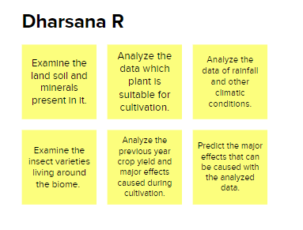

Team Member – Kavithanjali K has proposed the following Ideas

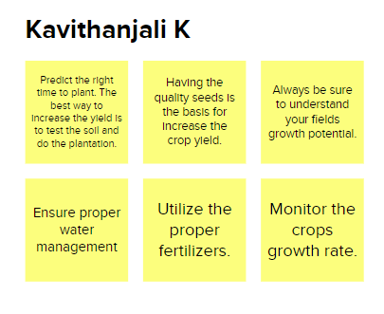

And the ideas are grouped into the following sub-areas

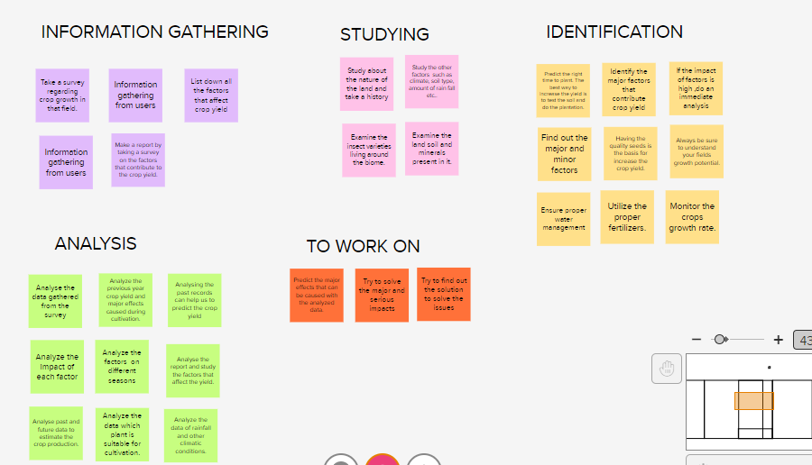

The sub-areas are Information Gathering, Studying, Identification, Analysis, and To work on

In Information Gathering sub-area, the following are grouped

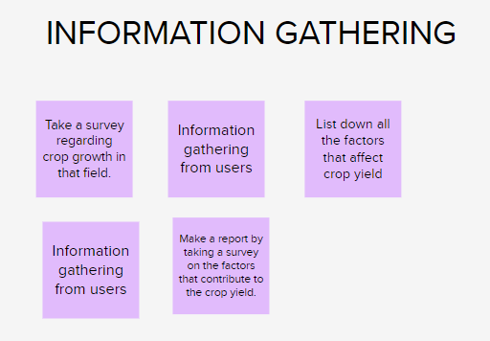

In Studying sub-area, the following are grouped

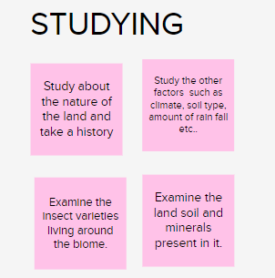

In Identification sub-area, the following are grouped

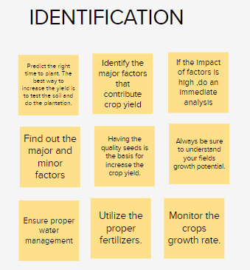

In Analysis sub-area, the following are grouped

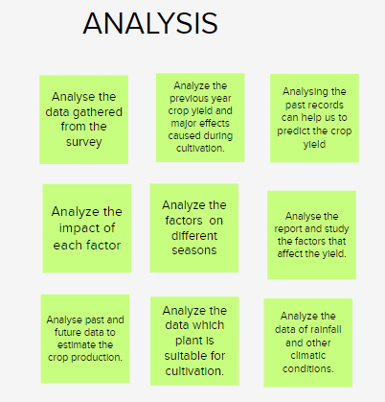

In To Work On sub-area, the following are grouped

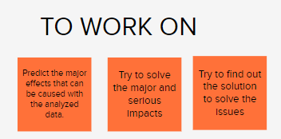

**Step-3: Idea Prioritization**

In the case of our project which is to estimate the crop yield using data analytics

